CSCI251 Assignment 3 Test Cases

Name : Yong Qin Toh
Student No. : 7059073

General Instructions

- Prepare the following :

- Setup the exact same version of your program that you submitted to Moodle (before deadline), inside Ubuntu OS

- Open up Excel document ‘CSCI251_A3_Checklist.xls‘

- Perform test cases SEQUENTIALLY on your program, do not skip steps / sequence!

- FOR EACH test case :

  - Perform the test case on your program

  - If your program ‘pass’ the test case

- Do screen capture, and paste the image in this document, (CSCI251_A3_Test_Cases.doc), where indicated

- Update CSCI251_A3_Checklist.xls (select ‘yes’) at the row corresponding to your test case

Else // i.e. program ‘fails’ the test case

- No need for screen capture (leave the section blank)

- Update CSCI251_A3_Checklist.xls (select ‘no’) at the row corresponding to your test case

- Note : Please RESIZE your screen capture, Adjust the Spacing such that each
test case begins on a new page !!

Note :

Before you begin, download the following files from Google Groups:

- messy.txt
- fn_template_testcase.cpp

Perform the following steps

- Startup your program

- Read in the data stored in messy.txt

- Note:

File messy.txt contains a total of 28 records only

8 records are duplicates, hence, your program should only display / output the 20 unique records!

*** V. V. V. IMPT NOTE #1 ***
When you download the above files, DO NOT open them in your host O.S.! If you open them in a host OS like Windows, the text editor may save them into a windows-compatible format and your Ubuntu C++ program will have problems reading the files! You should open / access these files ONLY in Ubuntu O.S.

*** V. V. V. IMPT NOTE #2 ***
If for some reason, your program cannot still read the above input filename, last resort is to use Ubuntu text editor 'gedit', copy and paste the contents of the above input filename into a separate filename (e.g. myInput.txt), and save it inside Ubuntu! This is guaranteed to ensure the contents of the files are saved in Ubuntu O.S. compatible format!

Test Case #1a – Data for criteria
‘Filter : Point2D, Sort by : X, Order : ASC’
displayed correctly

    - Specify the following criteria in your program :
- Filtering Criteria : Point2D
- Sorting Criteria : X Ordinate Value
- Sorting Order : ASC

    - Select “5) View data”

    - Paste a screen capture of the output

    - Verify the output against the values shown in the appropriate table (with the exact same criteria) in Appendix A

    - Update Excel file ‘CSCI251_A3_Checklist.xls’, select ‘Yes’ in column ‘C’, (for the 1st row corresponding to Test Case #1a), if your program’s results are verified to be correct as described in step d)

    - Update Excel file ‘CSCI251_A3_Checklist.xls’, select ‘Yes’ in column ‘C’, (for the 2nd row corresponding to Test Case #1a), if your program’s results shows the same format & alignment as shown in the appropriate table in Appendix A

< Paste Screen Capture(s) below >

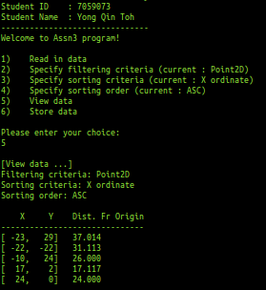

Test Case #1b – Data for criteria
‘Filter : Point2D, Sort by : X, Order : DSC’
displayed correctly

- Specify the following criteria in your program :
- Filtering Criteria : Point2D
- Sorting Criteria : X Ordinate Value
- Sorting Order : DSC

- Select “5) View data”

- Paste a screen capture of the output

- Verify the output against the values shown in the appropriate table (with the exact same criteria) in Appendix A

- Update Excel file ‘CSCI251_A3_Checklist.xls’, select ‘Yes’ in column ‘C’, (for the 1st row corresponding to Test Case #1b), if your program’s results are verified to be correct as described in step d)

- Update Excel file ‘CSCI251_A3_Checklist.xls’, select ‘Yes’ in column ‘C’, (for the 2nd row corresponding to Test Case #1b), if your program’s results shows the same format & alignment as shown in the appropriate table in Appendix A

< Paste Screen Capture(s) below >

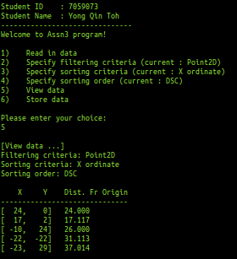

Test Case #1c – Data for criteria
‘Filter : Point2D, Sort by : Y, Order : ASC’
displayed correctly

- Specify the following criteria in your program :
- Filtering Criteria : Point2D
- Sorting Criteria : Y Ordinate Value
- Sorting Order : ASC

- Select “5) View data”

- Paste a screen capture of the output

- Verify the output against the values shown in the appropriate table (with the exact same criteria) in Appendix A

- Update Excel file ‘CSCI251_A3_Checklist.xls’, select ‘Yes’ in column ‘C’, (for the 1st row corresponding to Test Case #1c), if your program’s results are verified to be correct as described in step d)

- Update Excel file ‘CSCI251_A3_Checklist.xls’, select ‘Yes’ in column ‘C’, (for the 2nd row corresponding to Test Case #1c), if your program’s results shows the same format & alignment as shown in the appropriate table in Appendix A

< Paste Screen Capture(s) below >

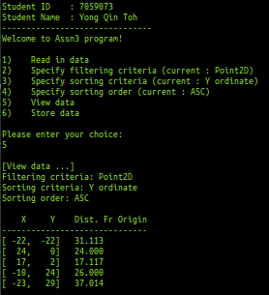

Test Case #1d – Data for criteria
‘Filter : Point2D, Sort by : Y, Order : DSC’
displayed correctly

- Specify the following criteria in your program :
- Filtering Criteria : Point2D
- Sorting Criteria : Y Ordinate Value
- Sorting Order : DSC

- Select “5) View data”

- Paste a screen capture of the output

- Verify the output against the values shown in the appropriate table (with the exact same criteria) in Appendix A

- Update Excel file ‘CSCI251_A3_Checklist.xls’, select ‘Yes’ in column ‘C’, (for the 1st row corresponding to Test Case #1d), if your program’s results are verified to be correct as described in step d)

- Update Excel file ‘CSCI251_A3_Checklist.xls’, select ‘Yes’ in column ‘C’, (for the 2nd row corresponding to Test Case #1d), if your program’s results shows the same format & alignment as shown in the appropriate table in Appendix A

< Paste Screen Capture(s) below >

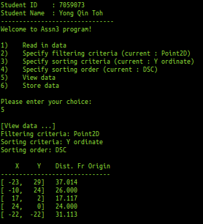

Test Case #1e – Data for criteria
‘Filter : Point2D, Sort by : DistFrOrigin, Order : ASC’
displayed correctly

- Specify the following criteria in your program :
- Filtering Criteria : Point2D
- Sorting Criteria : Dist. Fr Origin value
- Sorting Order : ASC

- Select “5) View data”

- Paste a screen capture of the output

- Verify the output against the values shown in the appropriate table (with the exact same criteria) in Appendix A

- Update Excel file ‘CSCI251_A3_Checklist.xls’, select ‘Yes’ in column ‘C’, (for the 1st row corresponding to Test Case #1e), if your program’s results are verified to be correct as described in step d)

- Update Excel file ‘CSCI251_A3_Checklist.xls’, select ‘Yes’ in column ‘C’, (for the 2nd row corresponding to Test Case #1e), if your program’s results shows the same format & alignment as shown in the appropriate table in Appendix A

< Paste Screen Capture(s) below >

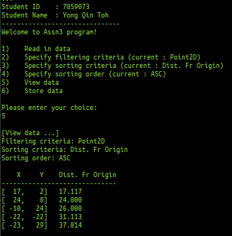

Test Case #1f – Data for criteria
‘Filter : Point2D, Sort by : DistFrOrigin, Order : DSC’
displayed correctly

- Specify the following criteria in your program :
- Filtering Criteria : Point2D
- Sorting Criteria : Dist. Fr Origin value
- Sorting Order : DSC

- Select “5) View data”

- Paste a screen capture of the output

- Verify the output against the values shown in the appropriate table (with the exact same criteria) in Appendix A

- Update Excel file ‘CSCI251_A3_Checklist.xls’, select ‘Yes’ in column ‘C’, (for the 1st row corresponding to Test Case #1f), if your program’s results are verified to be correct as described in step d)

- Update Excel file ‘CSCI251_A3_Checklist.xls’, select ‘Yes’ in column ‘C’, (for the 2nd row corresponding to Test Case #1f), if your program’s results shows the same format & alignment as shown in the appropriate table in Appendix A

< Paste Screen Capture(s) below >

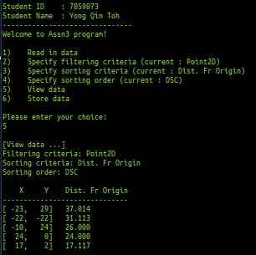

Test Case #2a – Data for criteria
‘Filter : Point3D, Sort by : X, Order : ASC’
displayed correctly

- Specify the following criteria in your program :
- Filtering Criteria : Point3D
- Sorting Criteria : X Ordinate Value
- Sorting Order : ASC

- Select “5) View data”

- Paste a screen capture of the output

- Verify the output against the values shown in the appropriate table (with the exact same criteria) in Appendix B

- Update Excel file ‘CSCI251_A3_Checklist.xls’, select ‘Yes’ in column ‘C’, (for the 1st row corresponding to Test Case #2a), if your program’s results are verified to be correct as described in step d)

- Update Excel file ‘CSCI251_A3_Checklist.xls’, select ‘Yes’ in column ‘C’, (for the 2nd row corresponding to Test Case #2a), if your program’s results shows the same format & alignment as shown in the appropriate table in Appendix B

< Paste Screen Capture(s) below >

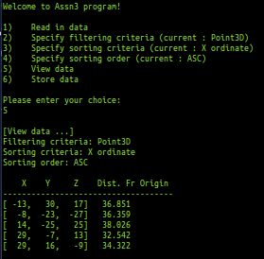

Test Case #2b – Data for criteria
‘Filter : Point3D, Sort by : X, Order : DSC’
displayed correctly

- Specify the following criteria in your program :
- Filtering Criteria : Point3D
- Sorting Criteria : X Ordinate Value
- Sorting Order : DSC

- Select “5) View data”

- Paste a screen capture of the output

- Verify the output against the values shown in the appropriate table (with the exact same criteria) in Appendix B

- Update Excel file ‘CSCI251_A3_Checklist.xls’, select ‘Yes’ in column ‘C’, (for the 1st row corresponding to Test Case #2b), if your program’s results are verified to be correct as described in step d)

- Update Excel file ‘CSCI251_A3_Checklist.xls’, select ‘Yes’ in column ‘C’, (for the 2nd row corresponding to Test Case #2b), if your program’s results shows the same format & alignment as shown in the appropriate table in Appendix B

< Paste Screen Capture(s) below >

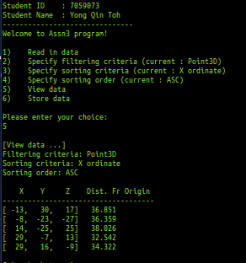

Test Case #2c – Data for criteria
‘Filter : Point3D, Sort by : Y, Order : ASC’
displayed correctly

- Specify the following criteria in your program :
- Filtering Criteria : Point3D
- Sorting Criteria : Y Ordinate Value
- Sorting Order : ASC

- Select “5) View data”

- Paste a screen capture of the output

- Verify the output against the values shown in the appropriate table (with the exact same criteria) in Appendix B

- Update Excel file ‘CSCI251_A3_Checklist.xls’, select ‘Yes’ in column ‘C’, (for the 1st row corresponding to Test Case #2c), if your program’s results are verified to be correct as described in step d)

- Update Excel file ‘CSCI251_A3_Checklist.xls’, select ‘Yes’ in column ‘C’, (for the 2nd row corresponding to Test Case #2c), if your program’s results shows the same format & alignment as shown in the appropriate table in Appendix B

< Paste Screen Capture(s) below >

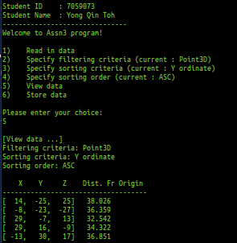

Test Case #2d – Data for criteria
‘Filter : Point3D, Sort by : Y, Order : DSC’
displayed correctly

- Specify the following criteria in your program :
- Filtering Criteria : Point3D
- Sorting Criteria : Y Ordinate Value
- Sorting Order : DSC

- Select “5) View data”

- Paste a screen capture of the output

- Verify the output against the values shown in the appropriate table (with the exact same criteria) in Appendix B

- Update Excel file ‘CSCI251_A3_Checklist.xls’, select ‘Yes’ in column ‘C’, (for the 1st row corresponding to Test Case #2d), if your program’s results are verified to be correct as described in step d)

- Update Excel file ‘CSCI251_A3_Checklist.xls’, select ‘Yes’ in column ‘C’, (for the 2nd row corresponding to Test Case #2d), if your program’s results shows the same format & alignment as shown in the appropriate table in Appendix B

< Paste Screen Capture(s) below >

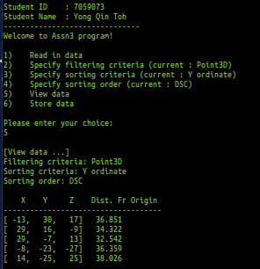

Test Case #2e – Data for criteria
‘Filter : Point3D, Sort by : Z, Order : ASC’
displayed correctly

- Specify the following criteria in your program :
- Filtering Criteria : Point3D
- Sorting Criteria : Z Ordinate Value
- Sorting Order : ASC

- Select “5) View data”

- Paste a screen capture of the output

- Verify the output against the values shown in the appropriate table (with the exact same criteria) in Appendix B

- Update Excel file ‘CSCI251_A3_Checklist.xls’, select ‘Yes’ in column ‘C’, (for the 1st row corresponding to Test Case #2e), if your program’s results are verified to be correct as described in step d)

- Update Excel file ‘CSCI251_A3_Checklist.xls’, select ‘Yes’ in column ‘C’, (for the 2nd row corresponding to Test Case #2e), if your program’s results shows the same format & alignment as shown in the appropriate table in Appendix B

< Paste Screen Capture(s) below >

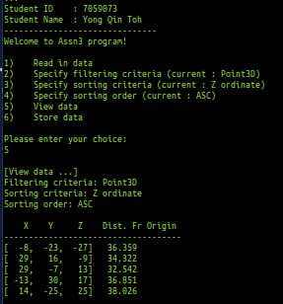

Test Case #2f – Data for criteria
‘Filter : Point3D, Sort by : Z, Order : DSC’
displayed correctly

- Specify the following criteria in your program :
- Filtering Criteria : Point3D
- Sorting Criteria : Z Ordinate Value
- Sorting Order : DSC

- Select “5) View data”

- Paste a screen capture of the output

- Verify the output against the values shown in the appropriate table (with the exact same criteria) in Appendix B

- Update Excel file ‘CSCI251_A3_Checklist.xls’, select ‘Yes’ in column ‘C’, (for the 1st row corresponding to Test Case #2f), if your program’s results are verified to be correct as described in step d)

- Update Excel file ‘CSCI251_A3_Checklist.xls’, select ‘Yes’ in column ‘C’, (for the 2nd row corresponding to Test Case #2f), if your program’s results shows the same format & alignment as shown in the appropriate table in Appendix B

< Paste Screen Capture(s) below >

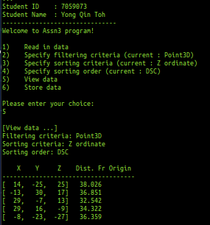

Test Case #2g – Data for criteria
‘Filter : Point3D, Sort by : DistFrOrigin, Order : ASC’
displayed correctly

- Specify the following criteria in your program :
- Filtering Criteria : Point3D
- Sorting Criteria : Dist. Fr Origin value
- Sorting Order : ASC

- Select “5) View data”

- Paste a screen capture of the output

- Verify the output against the values shown in the appropriate table (with the exact same criteria) in Appendix B

- Update Excel file ‘CSCI251_A3_Checklist.xls’, select ‘Yes’ in column ‘C’, (for the 1st row corresponding to Test Case #2g), if your program’s results are verified to be correct as described in step d)

- Update Excel file ‘CSCI251_A3_Checklist.xls’, select ‘Yes’ in column ‘C’, (for the 2nd row corresponding to Test Case #2g), if your program’s results shows the same format & alignment as shown in the appropriate table in Appendix B

< Paste Screen Capture(s) below >

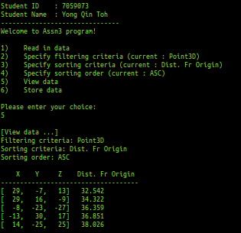

Test Case #2h – Data for criteria
‘Filter : Point3D, Sort by : DistFrOrigin, Order : DSC’
displayed correctly

- Specify the following criteria in your program :
- Filtering Criteria : Point3D
- Sorting Criteria : Dist. Fr Origin value
- Sorting Order : DSC

- Select “5) View data”

- Paste a screen capture of the output

- Verify the output against the values shown in the appropriate table (with the exact same criteria) in Appendix B

- Update Excel file ‘CSCI251_A3_Checklist.xls’, select ‘Yes’ in column ‘C’, (for the 1st row corresponding to Test Case #2h), if your program’s results are verified to be correct as described in step d)

- Update Excel file ‘CSCI251_A3_Checklist.xls’, select ‘Yes’ in column ‘C’, (for the 2nd row corresponding to Test Case #2h), if your program’s results shows the same format & alignment as shown in the appropriate table in Appendix B

< Paste Screen Capture(s) below >

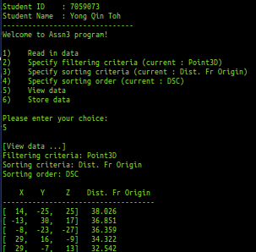

Test Case #3a – Data for criteria
‘Filter : Line2D, Sort by : Pt 1, Order : ASC’
displayed correctly

- Specify the following criteria in your program :
- Filtering Criteria : Line2D
- Sorting Criteria : Pt. 1’s (x, y) values
- Sorting Order : ASC

- Select “5) View data”

- Paste a screen capture of the output

- Verify the output against the values shown in the appropriate table (with the exact same criteria) in Appendix C

- Update Excel file ‘CSCI251_A3_Checklist.xls’, select ‘Yes’ in column ‘C’, (for the 1st row corresponding to Test Case #3a), if your program’s results are verified to be correct as described in step d)

- Update Excel file ‘CSCI251_A3_Checklist.xls’, select ‘Yes’ in column ‘C’, (for the 2nd row corresponding to Test Case #3a), if your program’s results shows the same format & alignment as shown in the appropriate table in Appendix C

< Paste Screen Capture(s) below >

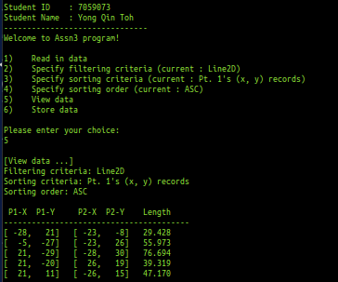

Test Case #3b – Data for criteria
‘Filter : Line2D, Sort by : Pt 1, Order : DSC’
displayed correctly

- Specify the following criteria in your program :
- Filtering Criteria : Line2D
- Sorting Criteria : Pt. 1’s (x, y) values
- Sorting Order : DSC

- Select “5) View data”

- Paste a screen capture of the output

- Verify the output against the values shown in the appropriate table (with the exact same criteria) in Appendix C

- Update Excel file ‘CSCI251_A3_Checklist.xls’, select ‘Yes’ in column ‘C’, (for the 1st row corresponding to Test Case #3b), if your program’s results are verified to be correct as described in step d)

- Update Excel file ‘CSCI251_A3_Checklist.xls’, select ‘Yes’ in column ‘C’, (for the 2nd row corresponding to Test Case #3b), if your program’s results shows the same format & alignment as shown in the appropriate table in Appendix C

< Paste Screen Capture(s) below >

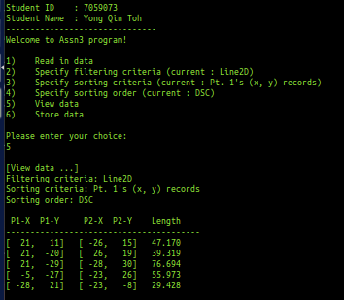

Test Case #3c – Data for criteria
‘Filter : Line2D, Sort by : Pt 2, Order : ASC’
displayed correctly

- Specify the following criteria in your program :
- Filtering Criteria : Line2D
- Sorting Criteria : Pt. 2’s (x, y) values
- Sorting Order : ASC

- Select “5) View data”

- Paste a screen capture of the output

- Verify the output against the values shown in the appropriate table (with the exact same criteria) in Appendix C

- Update Excel file ‘CSCI251_A3_Checklist.xls’, select ‘Yes’ in column ‘C’, (for the 1st row corresponding to Test Case #3c), if your program’s results are verified to be correct as described in step d)

- Update Excel file ‘CSCI251_A3_Checklist.xls’, select ‘Yes’ in column ‘C’, (for the 2nd row corresponding to Test Case #3c), if your program’s results shows the same format & alignment as shown in the appropriate table in Appendix C

< Paste Screen Capture(s) below >

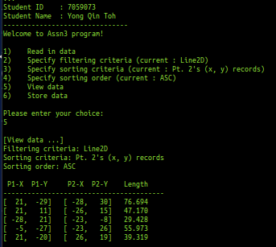

Test Case #3d – Data for criteria
‘Filter : Line2D, Sort by : Pt 2, Order : DSC’
displayed correctly

- Specify the following criteria in your program :
- Filtering Criteria : Line2D
- Sorting Criteria : Pt. 2’s (x, y) values
- Sorting Order : DSC

- Select “5) View data”

- Paste a screen capture of the output

- Verify the output against the values shown in the appropriate table (with the exact same criteria) in Appendix C

- Update Excel file ‘CSCI251_A3_Checklist.xls’, select ‘Yes’ in column ‘C’, (for the 1st row corresponding to Test Case #3d), if your program’s results are verified to be correct as described in step d)

- Update Excel file ‘CSCI251_A3_Checklist.xls’, select ‘Yes’ in column ‘C’, (for the 2nd row corresponding to Test Case #3d), if your program’s results shows the same format & alignment as shown in the appropriate table in Appendix C

< Paste Screen Capture(s) below >

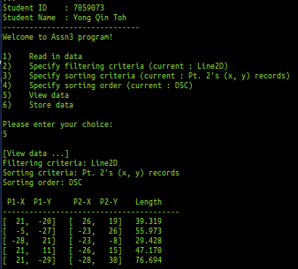

Test Case #3e – Data for criteria
‘Filter : Line2D, Sort by : Length, Order : ASC’
displayed correctly

- Specify the following criteria in your program :
- Filtering Criteria : Line2D
- Sorting Criteria : Length value
- Sorting Order : ASC

- Select “5) View data”

- Paste a screen capture of the output

- Verify the output against the values shown in the appropriate table (with the exact same criteria) in Appendix C

- Update Excel file ‘CSCI251_A3_Checklist.xls’, select ‘Yes’ in column ‘C’, (for the 1st row corresponding to Test Case #3e), if your program’s results are verified to be correct as described in step d)

- Update Excel file ‘CSCI251_A3_Checklist.xls’, select ‘Yes’ in column ‘C’, (for the 2nd row corresponding to Test Case #3e), if your program’s results shows the same format & alignment as shown in the appropriate table in Appendix C

< Paste Screen Capture(s) below >

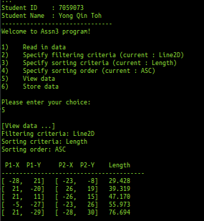

Test Case #3f – Data for criteria
‘Filter : Line2D, Sort by : Length, Order : DSC’
displayed correctly

- Specify the following criteria in your program :
- Filtering Criteria : Line2D
- Sorting Criteria : Length value
- Sorting Order : DSC

- Select “5) View data”

- Paste a screen capture of the output

- Verify the output against the values shown in the appropriate table (with the exact same criteria) in Appendix C

- Update Excel file ‘CSCI251_A3_Checklist.xls’, select ‘Yes’ in column ‘C’, (for the 1st row corresponding to Test Case #3f), if your program’s results are verified to be correct as described in step d)

- Update Excel file ‘CSCI251_A3_Checklist.xls’, select ‘Yes’ in column ‘C’, (for the 2nd row corresponding to Test Case #3f), if your program’s results shows the same format & alignment as shown in the appropriate table in Appendix C

< Paste Screen Capture(s) below >

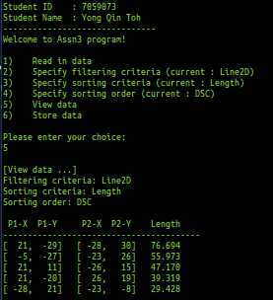

Test Case #4a – Data for criteria
‘Filter : Line3D, Sort by : Pt 1, Order : ASC’
displayed correctly

- Specify the following criteria in your program :
- Filtering Criteria : Line3D
- Sorting Criteria : Pt. 1’s (x, y) values
- Sorting Order : ASC

- Select “5) View data”

- Paste a screen capture of the output

- Verify the output against the values shown in the appropriate table (with the exact same criteria) in Appendix D

- Update Excel file ‘CSCI251_A3_Checklist.xls’, select ‘Yes’ in column ‘C’, (for the 1st row corresponding to Test Case #4a), if your program’s results are verified to be correct as described in step d)

- Update Excel file ‘CSCI251_A3_Checklist.xls’, select ‘Yes’ in column ‘C’, (for the 2nd row corresponding to Test Case #4a), if your program’s results shows the same format & alignment as shown in the appropriate table in Appendix D

< Paste Screen Capture(s) below >

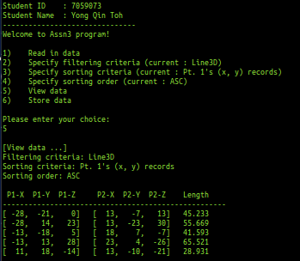

Test Case #4b – Data for criteria
‘Filter : Line3D, Sort by : Pt 1, Order : DSC’
displayed correctly

- Specify the following criteria in your program :
- Filtering Criteria : Line3D
- Sorting Criteria : Pt. 1’s (x, y) values
- Sorting Order : DSC

- Select “5) View data”

- Paste a screen capture of the output

- Verify the output against the values shown in the appropriate table (with the exact same criteria) in Appendix D

- Update Excel file ‘CSCI251_A3_Checklist.xls’, select ‘Yes’ in column ‘C’, (for the 1st row corresponding to Test Case #4b), if your program’s results are verified to be correct as described in step d)

- Update Excel file ‘CSCI251_A3_Checklist.xls’, select ‘Yes’ in column ‘C’, (for the 2nd row corresponding to Test Case #4b), if your program’s results shows the same format & alignment as shown in the appropriate table in Appendix D

< Paste Screen Capture(s) below >

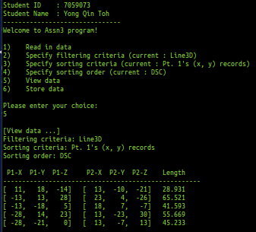

Test Case #4c – Data for criteria
‘Filter : Line3D, Sort by : Pt 2, Order : ASC’
displayed correctly

- Specify the following criteria in your program :
- Filtering Criteria : Line3D
- Sorting Criteria : Pt. 2’s (x, y) values
- Sorting Order : ASC

- Select “5) View data”

- Paste a screen capture of the output

- Verify the output against the values shown in the appropriate table (with the exact same criteria) in Appendix D

- Update Excel file ‘CSCI251_A3_Checklist.xls’, select ‘Yes’ in column ‘C’, (for the 1st row corresponding to Test Case #4c), if your program’s results are verified to be correct as described in step d)

- Update Excel file ‘CSCI251_A3_Checklist.xls’, select ‘Yes’ in column ‘C’, (for the 2nd row corresponding to Test Case #4c), if your program’s results shows the same format & alignment as shown in the appropriate table in Appendix D

< Paste Screen Capture(s) below >

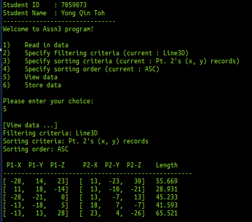

Test Case #4d – Data for criteria
‘Filter : Line3D, Sort by : Pt 2, Order : DSC’
displayed correctly

- Specify the following criteria in your program :
- Filtering Criteria : Line3D
- Sorting Criteria : Pt. 2’s (x, y) values
- Sorting Order : DSC

- Select “5) View data”

- Paste a screen capture of the output

- Verify the output against the values shown in the appropriate table (with the exact same criteria) in Appendix D

- Update Excel file ‘CSCI251_A3_Checklist.xls’, select ‘Yes’ in column ‘C’, (for the 1st row corresponding to Test Case #4d), if your program’s results are verified to be correct as described in step d)

- Update Excel file ‘CSCI251_A3_Checklist.xls’, select ‘Yes’ in column ‘C’, (for the 2nd row corresponding to Test Case #4d), if your program’s results shows the same format & alignment as shown in the appropriate table in Appendix D

< Paste Screen Capture(s) below >

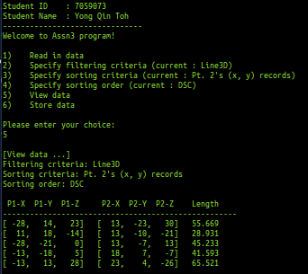

Test Case #4e – Data for criteria
‘Filter : Line3D, Sort by : Length, Order : ASC’
displayed correctly

- Specify the following criteria in your program :
- Filtering Criteria : Line3D
- Sorting Criteria : Length value
- Sorting Order : ASC

- Select “5) View data”

- Paste a screen capture of the output

- Verify the output against the values shown in the appropriate table (with the exact same criteria) in Appendix D

- Update Excel file ‘CSCI251_A3_Checklist.xls’, select ‘Yes’ in column ‘C’, (for the 1st row corresponding to Test Case #4e), if your program’s results are verified to be correct as described in step d)

- Update Excel file ‘CSCI251_A3_Checklist.xls’, select ‘Yes’ in column ‘C’, (for the 2nd row corresponding to Test Case #4e), if your program’s results shows the same format & alignment as shown in the appropriate table in Appendix D

< Paste Screen Capture(s) below >

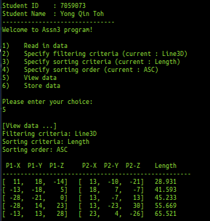

Test Case #4f – Data for criteria
‘Filter : Line3D, Sort by : Length, Order : DSC’
displayed correctly

- Specify the following criteria in your program :
- Filtering Criteria : Line3D
- Sorting Criteria : Length value
- Sorting Order : DSC

- Select “5) View data”

- Paste a screen capture of the output

- Verify the output against the values shown in the appropriate table (with the exact same criteria) in Appendix D

- Update Excel file ‘CSCI251_A3_Checklist.xls’, select ‘Yes’ in column ‘C’, (for the 1st row corresponding to Test Case #4f), if your program’s results are verified to be correct as described in step d)

- Update Excel file ‘CSCI251_A3_Checklist.xls’, select ‘Yes’ in column ‘C’, (for the 2nd row corresponding to Test Case #4f), if your program’s results shows the same format & alignment as shown in the appropriate table in Appendix D

< Paste Screen Capture(s) below >

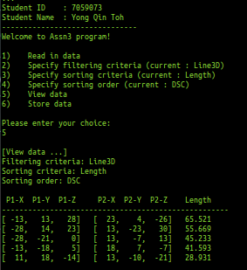

Test Case #5a – Data for criteria
‘Filter : Point2D, Sort by : DistFrOrigin, Order : DSC’
being SAVED correctly

- Specify the following criteria in your program :
- Filtering Criteria : Point2D
- Sorting Criteria : Dist. Fr Origin value
- Sorting Order : DSC

- Select “6) Store data”

- Save output as filename : "p2d_distFrOrigin_dsc.txt" (Note : Please include this file as part of your test case results submission!)

- Using any simple text editor, open up the file saved in previous step c)

- Verify the output against the values shown in the appropriate table (with the exact same criteria) in Appendix A

- Update Excel file ‘CSCI251_A3_Checklist.xls’, select ‘Yes’ in column ‘C’, (for the 1st row corresponding to Test Case #5a), if your program’s results are verified to be correct as described in step e)

< Paste Screen Capture(s) below >

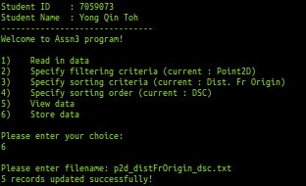

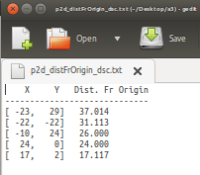

Test Case #5b – Data for criteria
‘Filter : Point3D, Sort by : Z, Order : ASC’
being SAVED correctly

- Specify the following criteria in your program :
- Filtering Criteria : Point3D
- Sorting Criteria : Z value
- Sorting Order : ASC

- Select “6) Store data”

- Save output as filename : "p3d_z_asc.txt" (Note : Please include this file as part of your test case results submission!)

- Using any simple text editor, open up the file saved in previous step c)

- Verify the output against the values shown in the appropriate table (with the exact same criteria) in Appendix A

- Update Excel file ‘CSCI251_A3_Checklist.xls’, select ‘Yes’ in column ‘C’, (for the 1st row corresponding to Test Case #5b), if your program’s results are verified to be correct as described in step e)

< Paste Screen Capture(s) below >

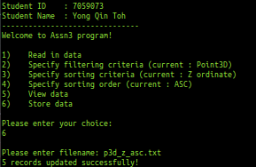

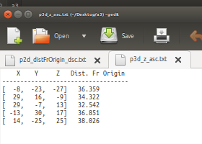

Test Case #5c – Data for criteria
‘Filter : Line2D, Sort by : Pt 2, Order : DSC’
being SAVED correctly

- Specify the following criteria in your program :
- Filtering Criteria : Line2D
- Sorting Criteria : Pt. 2’s (x, y) values
- Sorting Order : DSC

- Select “6) Store data”

- Save output as filename : "l2d_pt2_dsc.txt" (Note : Please include this file as part of your test case results submission!)

- Using any simple text editor, open up the file saved in previous step c)

- Verify the output against the values shown in the appropriate table (with the exact same criteria) in Appendix A

- Update Excel file ‘CSCI251_A3_Checklist.xls’, select ‘Yes’ in column ‘C’, (for the 1st row corresponding to Test Case #5c), if your program’s results are verified to be correct as described in step e)

< Paste Screen Capture(s) below >

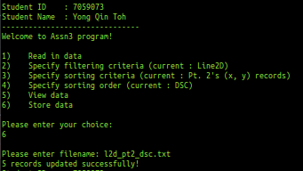

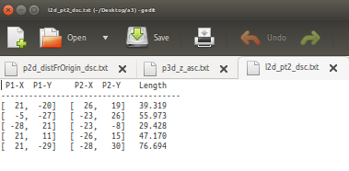

Test Case #5d – Data for criteria
‘Filter : Line3D, Sort by : Length, Order : ASC’
being SAVED correctly

- Specify the following criteria in your program :
- Filtering Criteria : Line3D
- Sorting Criteria : Length value
- Sorting Order : ASC

- Select “6) Store data”

- Save output as filename : "l3d_length_asc.txt" (Note : Please include this file as part of your test case results submission!)

- Using any simple text editor, open up the file saved in previous step c)

- Verify the output against the values shown in the appropriate table (with the exact same criteria) in Appendix A

- Update Excel file ‘CSCI251_A3_Checklist.xls’, select ‘Yes’ in column ‘C’, (for the 1st row corresponding to Test Case #5d), if your program’s results are verified to be correct as described in step e)

< Paste Screen Capture(s) below >

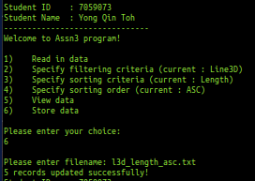

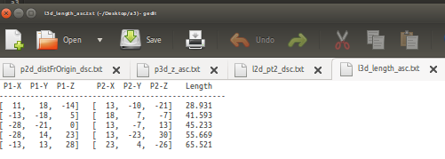

Note :

Before you proceed to test cases 6 and beyond, please perform the following steps:

- Use a simple text editor, open up “fn_template_testcase.cpp”

- Review the code inside the file

- Compile this program, together with your own files :
“Point2D.cpp”, “Point3D.cpp”, “Line2D.cpp”, “Line3D.cpp”,

Ensure all the necessary header files:
“MyTemplates.h”, “Point2D.h”, “Point3D.h”, “Line2D.h”, “Line3D.h”

are in the same folder as you compile!

- Run your program (e.g. type “a.out”)

- In the following page, paste as many screen captures as necessary, of the compiled program’s output

< Paste Screen Capture(s) below >

Test Case #6a to #6d – Verify the results for :
scalar_difference of
Point2D, Point3D, Line2D, Line3D are
displayed correctly

- Refer the screen capture(s) output

- Check the output’s values, against the respective output from Appendix E

- Update Excel file ‘CSCI251_A3_Checklist.xls’, the respective rows for testcases #6a to #6d, select ‘Yes’, if the answers from your screen capture matches those from Appendix E

Test Case #7a – Verify the results for :
equals of Point2D displayed correctly

- Refer the screen capture(s) output

- Check the output’s values, against the respective output from Appendix E

- Update Excel file ‘CSCI251_A3_Checklist.xls’, the respective row for testcase #7a, select ‘Yes’, if the answers from your screen capture matches those from Appendix E

Test Case #7b – Verify the results for :
equals of Point3D displayed correctly

- Refer the screen capture(s) output

- Check the output’s values, against the respective output from Appendix E

- Update Excel file ‘CSCI251_A3_Checklist.xls’, the respective row for testcases #7b, select ‘Yes’, if the answers from your screen capture matches those from Appendix E

Test Case #7c – Verify the results for :
equals of Line2D displayed correctly

- Refer the screen capture(s) output

- Check the output’s values, against the respective output from Appendix E

- Update Excel file ‘CSCI251_A3_Checklist.xls’, the respective row for testcase #7c, select ‘Yes’, if the answers from your screen capture matches those from Appendix E

Test Case #7d – Verify the results for :
equals of Line3D displayed correctly

- Refer the screen capture(s) output

- Check the output’s values, against the respective output from Appendix E

- Update Excel file ‘CSCI251_A3_Checklist.xls’, the respective row for testcase #7d, select ‘Yes’, if the answers from your screen capture matches those from Appendix E

(Optional) Extra Feature / Functionality / Value Add

Description
(In the space below, type a short summary to describe the extra feature(s) implemented)

< Paste Screen Capture(s) below >

(In the space below, use as many screen captures, MS Word arrows, textboxes, as necessary, to show that your extra feature(s) works!)

Appendix A

(Sorting and Ordering for Point2D class)

X Y Dist. Fr Origin
- - - - - - - - - - - - - - - -
[ -23, 29] 37.014
[ -22, -22] 31.113
[ -10, 24] 26.000
[ 17, 2] 17.117
[ 24, 0] 24.000
Point2D (Sort by X, ASC)
X Y Dist. Fr Origin
- - - - - - - - - - - - - - - -
[ 24, 0] 24.000
[ 17, 2] 17.117
[ -10, 24] 26.000
[ -22, -22] 31.113
[ -23, 29] 37.014

Point2D (Sort by X, DSC)

X Y Dist. Fr Origin
- - - - - - - - - - - - - - - -
[ -22, -22] 31.113
[ 24, 0] 24.000
[ 17, 2] 17.117
[ -10, 24] 26.000
[ -23, 29] 37.014
Point2D (Sort by Y, ASC)
X Y Dist. Fr Origin
- - - - - - - - - - - - - - - -
[ -23, 29] 37.014
[ -10, 24] 26.000
[ 17, 2] 17.117
[ 24, 0] 24.000
[ -22, -22] 31.113
Point2D (Sort by Y, DSC)

X Y Dist. Fr Origin
- - - - - - - - - - - - - - - -
[ 17, 2] 17.117
[ 24, 0] 24.000
[ -10, 24] 26.000
[ -22, -22] 31.113
[ -23, 29] 37.014
Point2D (Sort by Dist Fr Origin, ASC)
X Y Dist. Fr Origin
- - - - - - - - - - - - - - - -
[ -23, 29] 37.014
[ -22, -22] 31.113
[ -10, 24] 26.000
[ 24, 0] 24.000
[ 17, 2] 17.117
Point2D (Sort by Dist Fr Origin, DSC)

Appendix B

(Sorting and Ordering for Point3D class)

X Y Z Dist. Fr Origin
- - - - - - - - - - - - - - - - - - -
[ -13, 30, 17] 36.851
[ -8, -23, -27] 36.359
[ 14, -25, 25] 38.026
[ 29, 16, -9] 34.322
[ 29, -7, 13] 32.542
Point3D (Sort by X, ASC)

X Y Z Dist. Fr Origin
- - - - - - - - - - - - - - - - - - -
[ 29, -7, 13] 32.542
[ 29, 16, -9] 34.322
[ 14, -25, 25] 38.026
[ -8, -23, -27] 36.359
[ -13, 30, 17] 36.851
Point3D (Sort by X, DSC)

X Y Z Dist. Fr Origin
- - - - - - - - - - - - - - - - - - -
[ 14, -25, 25] 38.026
[ -8, -23, -27] 36.359
[ 29, -7, 13] 32.542
[ 29, 16, -9] 34.322
[ -13, 30, 17] 36.851
Point3D (Sort by Y, ASC)

X Y Z Dist. Fr Origin
- - - - - - - - - - - - - - - - - - -
[ -13, 30, 17] 36.851
[ 29, 16, -9] 34.322
[ 29, -7, 13] 32.542
[ -8, -23, -27] 36.359
[ 14, -25, 25] 38.026
Point3D (Sort by Y, DSC)

Appendix B (con’t)

(Sorting and Ordering for Point3D class)

X Y Z Dist. Fr Origin
- - - - - - - - - - - - - - - - - - -
[ -8, -23, -27] 36.359
[ 29, 16, -9] 34.322
[ 29, -7, 13] 32.542
[ -13, 30, 17] 36.851
[ 14, -25, 25] 38.026
Point3D (Sort by Z, ASC)

X Y Z Dist. Fr Origin
- - - - - - - - - - - - - - - - - - -
[ 14, -25, 25] 38.026
[ -13, 30, 17] 36.851
[ 29, -7, 13] 32.542
[ 29, 16, -9] 34.322
[ -8, -23, -27] 36.359
Point3D (Sort by Z, DSC)

X Y Z Dist. Fr Origin
- - - - - - - - - - - - - - - - - - -
[ 29, -7, 13] 32.542
[ 29, 16, -9] 34.322
[ -8, -23, -27] 36.359
[ -13, 30, 17] 36.851
[ 14, -25, 25] 38.026
Point3D (Sort by Dist Fr Origin, ASC)

X Y Z Dist. Fr Origin
- - - - - - - - - - - - - - - - - - -
[ 14, -25, 25] 38.026
[ -13, 30, 17] 36.851
[ -8, -23, -27] 36.359
[ 29, 16, -9] 34.322
[ 29, -7, 13] 32.542
Point3D (Sort by Dist Fr Origin, DSC)

Appendix C

(Sorting and Ordering for Line2D class)

P1-X P1-Y P2-X P2-Y Length
- - - - - - - - - - - - - - - - - - -
[ -28, 21] [ -23, -8] 29.428
[ -5, -27] [ -23, 26] 55.973
[ 21, -29] [ -28, 30] 76.694
[ 21, -20] [ 26, 19] 39.319
[ 21, 11] [ -26, 15] 47.170
Line2D (Sort by Pt 1, ASC)
P1-X P1-Y P2-X P2-Y Length
- - - - - - - - - - - - - - - - - - -
[ 21, 11] [ -26, 15] 47.170
[ 21, -20] [ 26, 19] 39.319
[ 21, -29] [ -28, 30] 76.694
[ -5, -27] [ -23, 26] 55.973
[ -28, 21] [ -23, -8] 29.428
Line2D (Sort by Pt 1, DSC)
P1-X P1-Y P2-X P2-Y Length
- - - - - - - - - - - - - - - - - - -
[ 21, -29] [ -28, 30] 76.694
[ 21, 11] [ -26, 15] 47.170
[ -28, 21] [ -23, -8] 29.428
[ -5, -27] [ -23, 26] 55.973
[ 21, -20] [ 26, 19] 39.319
Line2D (Sort by Pt 2, ASC)
P1-X P1-Y P2-X P2-Y Length
- - - - - - - - - - - - - - - - - - -
[ 21, -20] [ 26, 19] 39.319
[ -5, -27] [ -23, 26] 55.973
[ -28, 21] [ -23, -8] 29.428
[ 21, 11] [ -26, 15] 47.170
[ 21, -29] [ -28, 30] 76.694
Line2D (Sort by Pt 2, DSC)

Appendix C (con’t)

(Sorting and Ordering for Line2D class)

P1-X P1-Y P2-X P2-Y Length
- - - - - - - - - - - - - - - - - - -
[ -28, 21] [ -23, -8] 29.428
[ 21, -20] [ 26, 19] 39.319
[ 21, 11] [ -26, 15] 47.170
[ -5, -27] [ -23, 26] 55.973
[ 21, -29] [ -28, 30] 76.694
Line2D (Sort by Length, ASC)

P1-X P1-Y P2-X P2-Y Length
- - - - - - - - - - - - - - - - - - -
[ 21, -29] [ -28, 30] 76.694
[ -5, -27] [ -23, 26] 55.973
[ 21, 11] [ -26, 15] 47.170
[ 21, -20] [ 26, 19] 39.319
[ -28, 21] [ -23, -8] 29.428
Line2D (Sort by Length, DSC)

Appendix D

(Sorting and Ordering for Line3D class)

P1-X P1-Y P1-Z P2-X P2-Y P2-Z Length
- - - - - - - - - - - - - - - - - - - - - - - - - - -
[ -28, -21, 0] [ 13, -7, 13] 45.233
[ -28, 14, 23] [ 13, -23, 30] 55.669
[ -13, -18, 5] [ 18, 7, -7] 41.593
[ -13, 13, 28] [ 23, 4, -26] 65.521
[ 11, 18, -14] [ 13, -10, -21] 28.931
Line3D (Sort by Pt 1, ASC)

P1-X P1-Y P1-Z P2-X P2-Y P2-Z Length
- - - - - - - - - - - - - - - - - - - - - - - - - - -
[ 11, 18, -14] [ 13, -10, -21] 28.931
[ -13, 13, 28] [ 23, 4, -26] 65.521
[ -13, -18, 5] [ 18, 7, -7] 41.593
[ -28, 14, 23] [ 13, -23, 30] 55.669
[ -28, -21, 0] [ 13, -7, 13] 45.233
Line3D (Sort by Pt 1, DSC)

P1-X P1-Y P1-Z P2-X P2-Y P2-Z Length
- - - - - - - - - - - - - - - - - - - - - - - - - - -
[ -28, 14, 23] [ 13, -23, 30] 55.669
[ 11, 18, -14] [ 13, -10, -21] 28.931
[ -28, -21, 0] [ 13, -7, 13] 45.233
[ -13, -18, 5] [ 18, 7, -7] 41.593
[ -13, 13, 28] [ 23, 4, -26] 65.521
Line3D (Sort by Pt 2, ASC)
P1-X P1-Y P1-Z P2-X P2-Y P2-Z Length
- - - - - - - - - - - - - - - - - - - - - - - - - - -
[ -13, 13, 28] [ 23, 4, -26] 65.521
[ -13, -18, 5] [ 18, 7, -7] 41.593
[ -28, -21, 0] [ 13, -7, 13] 45.233
[ 11, 18, -14] [ 13, -10, -21] 28.931
[ -28, 14, 23] [ 13, -23, 30] 55.669
Line3D (Sort by Pt 2, DSC)

Appendix D (con’t)

(Sorting and Ordering for Line3D class)

P1-X P1-Y P1-Z P2-X P2-Y P2-Z Length
- - - - - - - - - - - - - - - - - - - - - - - - - - -
[ 11, 18, -14] [ 13, -10, -21] 28.931
[ -13, -18, 5] [ 18, 7, -7] 41.593
[ -28, -21, 0] [ 13, -7, 13] 45.233
[ -28, 14, 23] [ 13, -23, 30] 55.669
[ -13, 13, 28] [ 23, 4, -26] 65.521
Line3D (Sort by Length, ASC)

P1-X P1-Y P1-Z P2-X P2-Y P2-Z Length
- - - - - - - - - - - - - - - - - - - - - - - - - - -
[ -13, 13, 28] [ 23, 4, -26] 65.521
[ -28, 14, 23] [ 13, -23, 30] 55.669
[ -28, -21, 0] [ 13, -7, 13] 45.233
[ -13, -18, 5] [ 18, 7, -7] 41.593
[ 11, 18, -14] [ 13, -10, -21] 28.931
Line3D (Sort by Length, DSC)

Appendix E

(Output from “fn_template_testcase.cpp” program)

scalar_difference betw. [1, 24], distFrOrigin : 24.021 and [23, -3], distFrOrigin : 23.195 is
0.826

scalar_difference betw. [12, 3, 14], distFrOrigin : 18.682 and [15, 3, -22], distFrOrigin : 26.796 is
8.114

scalar_difference betw. Line2D [-21, -9] to [-22, 8] is
46.052

scalar_difference betw. Line3D [-5, 25] to [-3, 7] is
13.015

equals (
[4, 17], distFrOrigin : 17.464,
[4, 17], distFrOrigin : 17.464 ) returns
true

equals (
[23, 26, 16], distFrOrigin : 38.223,
[23, 26, 16], distFrOrigin : 38.223 ) returns
true

equals (
Line2D [-21, -9] to [-27, -13], length : 7.211 AND
Line2D [-21, -9] to [-27, -13], length : 7.211 ) returns
true

equals (
Line3D [-5, 25, 23] to [4, 0, 5], length : 32.094 AND
Line3D [-5, 25, 23] to [4, 0, 5], length : 32.094 returns
true

